BRACTs

Vishwakarma Institute Of Information Technology,Kondhwa(BK),

Pune-48

Department of Computer Engineering



Database Management System

Project

On

**Recipe Generator**

SY Btech Computer Engineering

Academic Year:2023-24

Group No.:6

Group Members:

|  |  |  |  |
| --- | --- | --- | --- |
| **Sr.No** | **Roll No.** | **GR. No.** | **Name of Student** |
| 1 | 224053 | 22210159 | Sarvesh Pantoji |
| 2 | 224064 | 22211405 | Jay Shinde |
| 3 | 224068 | 22210271 | Sanika Shinde |
| 4 | 224078 | 22211041 | Deepak Walunj |

Faculty Mentor:

**Mr. Y. K. Sharma**

**Index**

|  |  |  |
| --- | --- | --- |
| **Serial No.** | **Topic** | **Page No.** |
| 1. | Title Page | 1 |
| 2. | Index Page | 2 |
| 3. | Abstract and objectives of project | 3 |
| 4. | Introduction(Including Literature Survey) | 4 |
| 5. | Software Requirement | 6 |
| 6. | E-R Diagram | 9 |
| 7. | Screen Snapshots of project | 10 |
| 8. | Conclusion | 13 |
| 9. | Future Scope | 14 |
| 10. | References | 15 |

**Abstract**

The development and implementation of a recipe generator web application using HTML, CSS, MySQL for database administration, and Python Flask for communication are presented in this research paper. The project intends to give customers an easy-to-use platform for discovering a range of dishes from three different cuisines, each featuring twelve different recipes. The application has user authentication built in, thus in order to view all of the recipe data, users must log in. The only thing that unauthorized users can see is the list of ingredients for every recipe. To make administration duties easier, such managing user accounts and updating recipe information, an admin login page is also implemented. The project's technical elements are covered in this article, including the database design, front-end development, architecture, and back-end implementation using flask. In addition, it gives culinary aficionados looking for inspiration and direction in their cooking undertakings a glimpse into the user experience and advantages of using this recipe generator.

**Objective**

The primary objective of this research project is to develop a Recipe Generator Web Application that leverages HTML, CSS for frontend design, MySQL for database management, and Python Flask for connectivity. The specific goals of the project are as follows:

1. Design and implement an intuitive user interface using HTML and CSS to ensure an engaging and visually appealing experience for users interacting with the application.
2. Develop a MySQL database schema to store and manage recipe data, including information about cuisines, recipes, ingredients, and user accounts.
3. Utilize Python Flask to establish connectivity between the frontend interface, backend logic, and the MySQL database, enabling seamless interaction and data retrieval.
4. Categorize recipes into three distinct cuisines, with each cuisine containing twelve unique recipes, selected to represent a diverse range of culinary experiences.
5. Implement user authentication functionality to restrict access to detailed recipe procedures, allowing only authenticated users to explore the entire recipe process. Unauthorized users should be limited to viewing only the ingredients list.
6. Incorporate an admin login page to facilitate administrative tasks such as managing user accounts, updating recipe information, and ensuring the integrity of the application.
7. Ensure scalability, security, and performance optimization throughout the development process to enhance the overall reliability and usability of the Recipe Generator Web Application.

**Introduction**

The world of cooking is full with many different flavors, preparation methods, and cultural customs from different parts of the world's cuisines. The growing dependence on digital platforms for guidance and information necessitates the need for effective and user-friendly tools for recipe exploration and discovery. This research paper presents a Recipe Generator Web Application created with HTML, CSS, and Python Flask for front-end design, database management, and networking. The application was created in answer to this demand.

This project's main goal is to give consumers a comprehensive platform to discover a large number of recipes. The recipes are divided into three different cuisines, each containing twelve unique recipes. The program makes sure users have to log in in order to view the comprehensive recipe methods. This is achieved by integrating user authentication features. Unauthorized users are discouraged from interacting with the site by being restricted to accessing the ingredients list for each dish.

Additionally, adding an admin login page makes it easier to handle administrative duties like changing recipe information and managing user accounts, which improves the application's general usefulness and usability. We examine the technical nuances of creating the recipe generator in this research paper, covering topics like database design, front-end development, architecture, and Flask back-end implementation.

We also talk about how important it is to have a recipe generator like this to serve home cooks, amateur chefs, and culinary lovers who are looking for ideas and direction for their cooking projects. Through the utilization of digital technology, this web application seeks to facilitate access to a wide range of culinary experiences, encourage culinary innovation, and advance cross-cultural communication via the common medium of food.

This research paper provides a thorough review of the Recipe Generator Web Application, including information on its features, development process, and possible influence on foodies all over the world. This project demonstrates the convergence of technology and gastronomy by combining frontend design, database management, and backend connectivity to provide users worldwide with a smooth and immersive culinary experience.

**Literature Survey**

"An update on cooking recipe generation with machine learning and natural language processing" examines the developments in the fields of natural language processing (NLP) and machine learning (ML) in the creation of culinary recipes. It is probable that the writers explore contemporary advancements in algorithms for generating recipes, going into techniques including transformer-based models like GPT, generative adversarial networks (GANs), and recurrent neural networks (RNNs). They might also discuss the difficulties and possibilities in this area, including user preferences, recipe coherence, and ingredient substitution. The study may also highlight the possible uses of recipe development, such as automated cooking aids, customized meal planning, and support for creative cooking.[[3](https://www.researchgate.net/publication/362941097_An_update_on_cooking_recipe_generation_with_Machine_Learning_and_Natural_Language_Processing)]

The concept of "Cooking recipes generator utilizing a deep learning-based language model" is examined in this work, which looks into the creation of such a tool. It probably describes the model's architecture and training procedure; it might be built on transformer-based models like GPT, generative adversarial networks (GANs), or recurrent neural networks (RNNs). Creating logical and believable recipes by machine learning from preexisting recipe databases is probably the main goal. The issues of component combination, creating cooking directions, and modeling user preferences might also be covered in the paper. Furthermore, it probably illustrates how a system like this may help consumers plan their meals and spark their creative juices.[[1](https://www.researchgate.net/publication/345308878_Cooking_recipes_generator_utilizing_a_deep_learning-based_language_model)]

It is possible that the research article "Recipe Generator using Deep Learning" investigates the use of deep learning methods in the development of a recipe generator. It most likely describes the architecture of the model, which may be transformer-based models such as GPT, generative adversarial networks (GANs), or recurrent neural networks (RNNs). The difficulties in creating logical and believable recipes, such as choosing ingredients and creating cooking instructions, are probably covered in the paper. It might also discuss how such a system might be used to help with meal planning and encourage culinary creativity. However, it's challenging to offer precise information on the literature survey inside the research without having access to the entire manuscript.[[2](https://www.ijraset.com/research-paper/recipe-generator-using-deep-learning)]

The project's integration of HTML for frontend development and MySQL for backend database management reflects a pragmatic approach rooted in established web development practices. Leveraging the flexibility and versatility of Python Flask for connectivity adds another layer of sophistication to the project's architecture, facilitating seamless interaction between the frontend and backend components. Additionally, the inclusion of features such as login, signup, and admin pages underscores the project's commitment to user-centric design principles, ensuring a smooth and intuitive user experience. Moreover, the provision of bookmarked recipes for logged-in users further enhances the application's utility and user engagement, aligning with contemporary trends in web application development aimed at fostering user loyalty and retention.

In essence, the synthesis of insights from these research papers and the project's implementation of cutting-edge techniques in deep learning, NLP, and web development converge to form a holistic and innovative solution to the perennial challenge of recipe generation. By embracing the latest advancements in technology and design, the project aspires to not only meet but exceed user expectations, thereby heralding a new era in the realm of culinary exploration and experimentation.

**Software Required**

1. **HTML and CSS:**

HTML (Hypertext Markup Language) and CSS (Cascading Style Sheets) are fundamental technologies used in web development, playing essential roles in creating visually appealing and interactive user interfaces.

**HTML (Hypertext Markup Language):**

* HTML serves as the backbone of web pages, providing the structure and organization of content.
* It uses a system of tags to define the various elements of a webpage, such as headings, paragraphs, lists, images, forms, and links.
* Through semantic markup, HTML ensures proper accessibility and search engine optimization (SEO) by structuring content in a meaningful way.
* HTML provides the foundation upon which CSS styles are applied to enhance the visual presentation and layout of the webpage.

**CSS (Cascading Style Sheets):**

* CSS is responsible for styling the HTML elements, defining their appearance, layout, and behavior on the webpage.
* It allows developers to control aspects such as fonts, colors, spacing, borders, backgrounds, and positioning.
* CSS enables the creation of responsive designs that adapt to different screen sizes and devices, enhancing user experience across various platforms.
* Through the use of selectors and rules, CSS provides a powerful mechanism for applying styles consistently throughout a website, ensuring a cohesive and professional look.
* CSS also supports animations and transitions, enabling developers to add interactive elements and visual effects to enhance user engagement.

Together, HTML and CSS work in tandem to create visually appealing, accessible, and user-friendly interfaces for web applications. HTML provides the structure and semantics, while CSS adds the aesthetic and stylistic enhancements, resulting in an engaging and immersive user experience. By leveraging the capabilities of HTML and CSS, developers can design interfaces that not only meet functional requirements but also captivate and delight users with their visual appeal and interactivity.

1. **Mysql for database management:**

In the Recipe Generator Project, the MySQL database comprises six interconnected tables: cuisine, Recipe, userlogin, bookmark, and ingredient_recipe. Each table serves a specific purpose and is linked to others through relationships to facilitate data management and retrieval. Here's an overview of the tables and their interconnections:

1.Cuisine table:

* Stores information about different cuisines.
* Columns may include cuisine_id (primary key), cuisine_name, description, etc.
* This table provides a base for categorizing recipes into different cuisines.

2.Recipe table:

* + Contains details about individual recipes.
  + Columns may include recipe_id (primary key), recipe_name, cuisine_id (foreign key referencing cuisine table), instructions, etc.
  + Establishes a relationship with the cuisine table to associate recipes with specific cuisines.

3.user table:

* + Stores user authentication information.
  + Columns may include user_id (primary key), username, password_hash, email, etc.
  + Enables user authentication and login functionality.

4.Bookmark table:

* Facilitates the bookmarking feature, allowing users to save their favorite recipes.
* Columns may include bookmark_id (primary key), user_id (foreign key referencing userlogin table), recipe_id (foreign key referencing recipe table), timestamp, etc.
* Represents a many-to-many relationship between users and recipes, indicating which recipes each user has bookmarked.

5.Ingredient-recipe table:

* Manages the relationship between recipes and their respective ingredients.
* Columns may include ingredient_recipe_id (primary key), recipe_id (foreign key referencing recipe table), ingredient_name, quantity, measurement_units, etc.
* Enables storing and retrieving ingredient details for each recipe, supporting the display of recipe ingredients on the frontend interface.

6.Ingredient table:

* Columns: ingredient_id (Primary Key), ingredient_name.
* Description: Stores information about ingredients used in recipes. Each ingredient may be associated with multiple recipes.

These tables are interconnected through foreign key constraints, establishing relationships between entities and ensuring data integrity. For example:

The Recipe table references the cuisine table through the cuisine_id foreign key, linking each recipe to its respective cuisine.The bookmark table connects users to their bookmarked recipes via foreign keys referencing the userlogin and recipe tables.The ingredient_recipe table is associated with the Recipe table through the recipe_id foreign key, allowing ingredients to be linked to specific recipes.By interconnecting these tables, the database structure facilitates efficient storage, retrieval, and manipulation of data, supporting the functionality of the Recipe Generator Project and enhancing the user experience.

**III.Python flask connectivity:**

In the Recipe Generator Project, Flask is essential to establishing communication between the database, server-side logic, and frontend interface. This is how Flask makes this connectivity possible:

1. Routing and URL handling: Flask offers a way to define routes that associate URLs with particular Python code functions. The frontend interface's routes function as endpoints for managing incoming HTTP requests. Routes can be set up to handle requests for user authentication, recipe bookmarking, recipe details display, and other functions.
2. Template Rendering: Using information obtained from the database, Flask dynamically generates HTML content by integrating with Jinja2, a potent templating engine, in a smooth manner. Using templates, developers can make reusable parts for displaying dynamic content, like user profiles, login forms, or recipes. By rendering these templates with context variables, Flask makes it possible to generate dynamic content using information retrieved from the backend.
3. Database Interaction: Flask uses a number of extensions and libraries to make it easier to communicate with the MySQL database. The ORM (Object-Relational Mapping) extension for Flask, Flask-SQLAlchemy, allows developers to construct models that reflect database tables and carry out CRUD (Create, Read, Update, Delete) operations on them. By abstracting away the complexities of SQL queries, SQLAlchemy improves the intuitiveness and Pythonics of database interface.
4. User Authentication and Session Management: Managing user sessions and putting authentication methods in place are supported natively by Flask. Developers may safely store user session data, including user IDs or authentication tokens, by utilizing Flask's session management features. Furthermore, Flask provides extensions such as Flask-Login to effectively handle user authentication and user session management.
5. Form Handling and Validation: Flask offers extensions such as Flask-WTF (Flask-Web Forms) that make form handling and validation easier. It is simpler to handle user input from frontend forms when developers can create and validate forms using Python classes, thanks to Flask-WTF. Assuring data integrity and security, this permits strong data validation and error management.

All in all, Flask serves as a conduit for smooth communication and interaction between the Recipe Generator Project's frontend UI, database, and server-side functionality. Flask is the best option for creating web applications with sophisticated backend features like user authentication, database interaction, and dynamic content rendering because of its simplicity, flexibility, and wide ecosystem of extensions.

**ER Diagram**

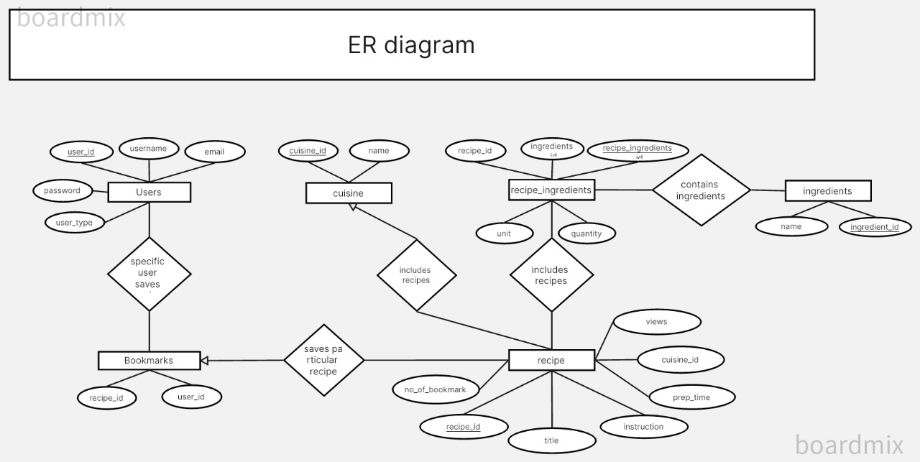

**Screen Snapshots of Project**

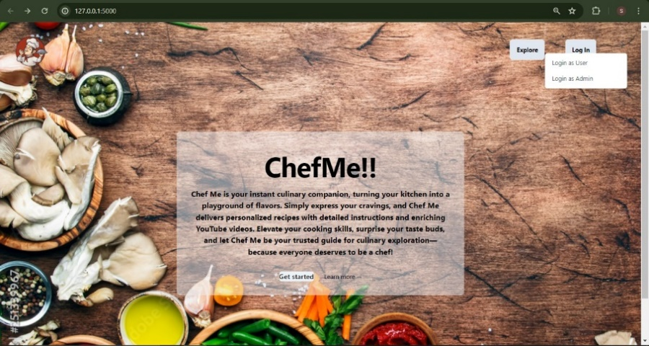

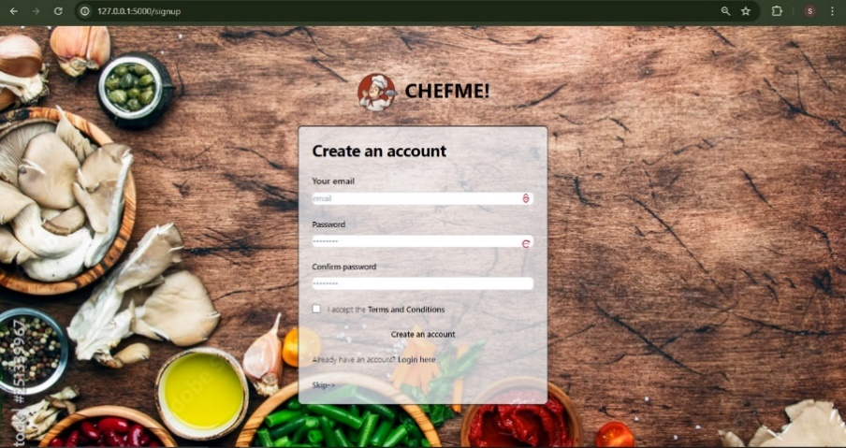

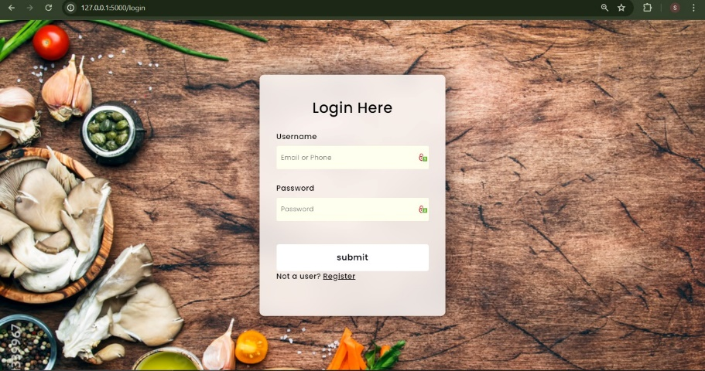

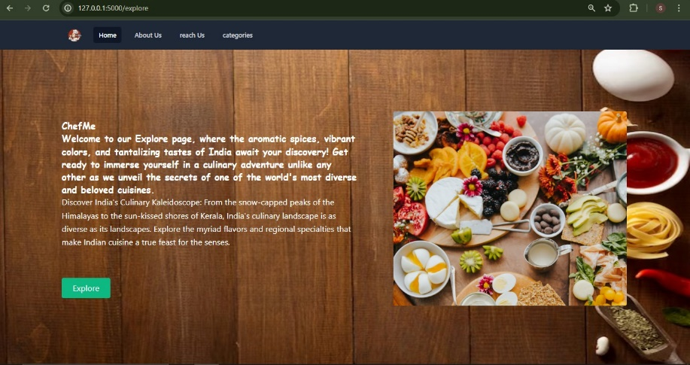

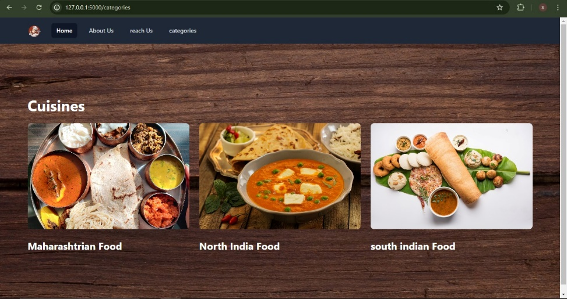

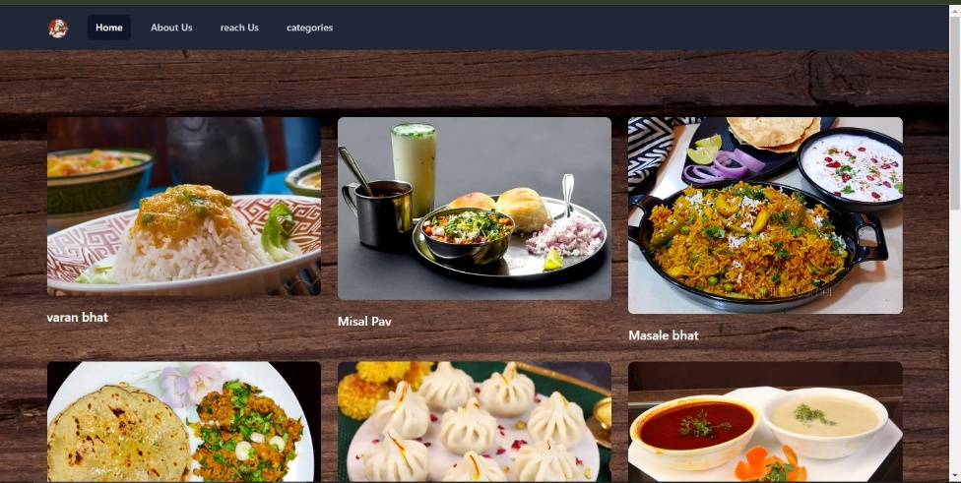

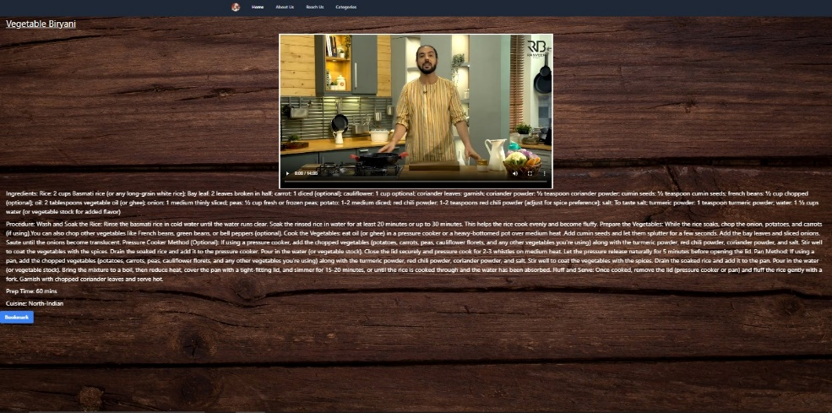

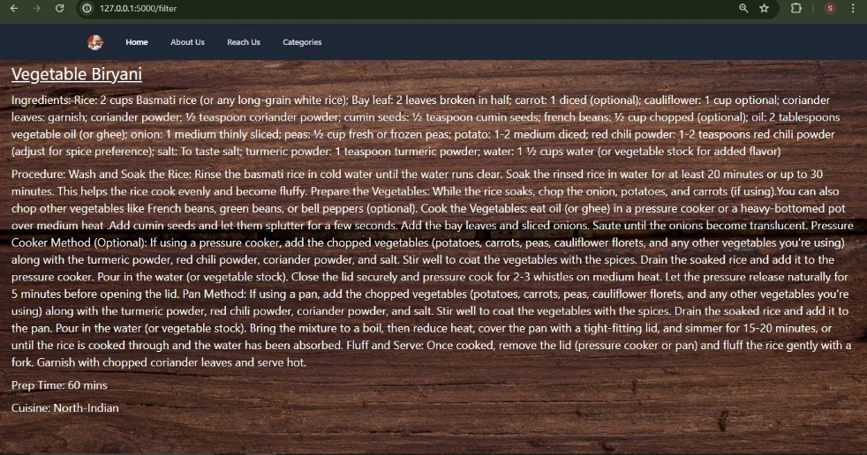

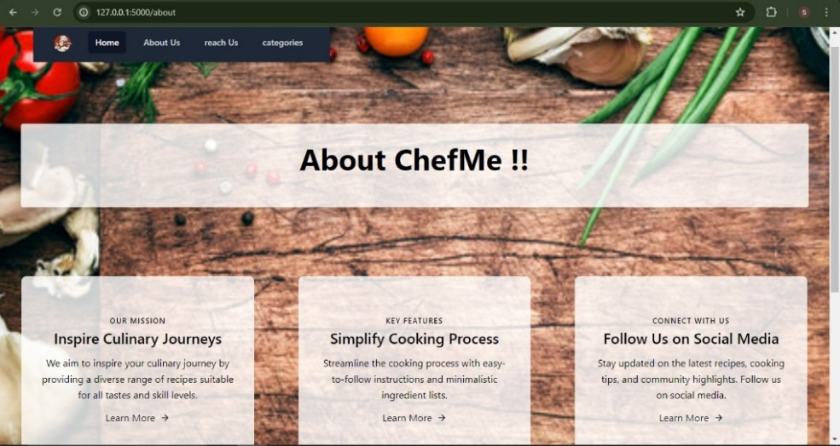

**Conclusion**

The creation of the Recipe Generator Project is an example of how contemporary digital technologies have come together to improve the culinary exploration experience. Using HTML, CSS, Python Flask, and MySQL, we have developed a dynamic and intuitive platform that makes it easier to find a wide variety of recipes from different cuisines.   
The web application's architecture was created with efficiency and scalability in mind, with separate frontend, backend, and database components collaborating flawlessly. With the purpose of preserving data integrity and facilitating effective data retrieval, the MySQL database schema has been meticulously designed to accommodate features like ingredient tracking, recipe administration, and user authentication.The goal of frontend development is to create an intuitive user interface that puts an emphasis on visual aesthetics and usability to make browsing enjoyable for users. Routing, authentication, and database interaction are handled by the backend implementation, which offers strong functionality while upholding security and dependability. The development method places a high priority on user authentication, varying access levels, and administrative features. This way, users can only see the full recipe procedures after logging in, while unauthorized people can only read the ingredient lists. Administrators can effectively manage user accounts, change recipe information, and carry out other administrative duties by using the admin login page.

**Future Scope**

The research paper's discussion of the Recipe Generator Web Application offers a strong case for further development. Through the addition of various cuisines and popular meals to the recipe database, the customization of recommendations, and the promotion of community involvement, the platform may serve a wider range of food fans. The introduction of mobile applications, nutritional analysis, and interactive culinary experiences can all greatly improve accessibility and user experience. Further opportunities for growth and sustainability include localization initiatives, integration with smart kitchen appliances, and monetization strategy exploration. By incorporating user feedback and proactive updates, the program is continuously improved, keeping it at the forefront of culinary technology and offering users a seamless and immersive cooking experience wherever.

**References**

1. Bień, M. (2020, February). Retrieved from Cooking recipes generator utilizing a deep learning-based language model: https://www.researchgate.net/publication/345308878_Cooking_recipes_generator_utilizing_a_deep_learning-based_language_model
2. Disha Moolya, S. P.-K. (2022, June). Retrieved from Recipe Generator using Deep Learning: https://www.ijraset.com/research-paper/recipe-generator-using-deep-learning
3. Galanis, N.-I. (2022, June). Retrieved from An update on cooking recipe generation with Machine Learning and Natural Language Processing: https://www.researchgate.net/publication/362941097_An_update_on_cooking_recipe_generation_with_Machine_Learning_and_Natural_Language_Processing